User Guide

jWebSocket
Stock Ticker Demo

Author and version history is missing, please add.

1. Characteristics of the solution
Stock Ticker Demo is an application that shows and promotes data in real time by means of a stock ticker. Allows users to see the behavior of the quotations of the companies as well as do purchase and sale, also view using a graph the behavior of your deposit purchases. The benefits that offers the users are that, obtaining the data of the quotations in a more efficient way augments the trust on time of taking purchase of decisions-blows of actions diminishing the loss of add financial. I do not understand this sentence. The benefits are to obtain quotations in real-time to support quick decisions on selling and purchasing stocks and other instruments, especially in day-trading environments, and to avoid loss in quick evolving markets.
Stock Ticker Demo is a carried out application by means of the protocol of WebSocket communication, which furnish that achieves show it data of the tables in real time providing a high level of speed and scalability.
jWebSocket is the framework in which the application was developed, showing the potentials that this one offers to promote data of the boards of quotations in the web in real time.
The level of scalability of the supported connections for the jWebSocket servants permits high concurrence of users. Proofs of stress tests showed that a jWebSocket server can serve 10 000 connect persons in attendance without affecting the time of answer of the application. This become muddled guarantees not single carry out processes in real time but can guarantee a high number of users using a same service in the same instant of time, which it means that 10 000 appear in person in the whole world it is able to access to the Ticker Demo stock application.
2. Main functionalities
Functionalities of Stock Ticker Demo:
1. Show stock ticker.
2. Show historial.
3. Buying instruments.
4. Selling instruments.
5. Chart deposits.
6. Show deposits.
7. Registering user.
8. Authenticating user.

Stock Ticker Demo is used principally in the financial sector. It is a fundamental element for takes it of agile and efficient decisions, represented great advantage in the worldwide market, since it informes the users about the financial state of the underlyings in the depot, moreover take important decisions of purchase and sale of actions of the same thing. It is of great help to investors and businessmen facilitating take them the control of his investments and financial states in real time.
3. Problems to be solved
Problem | Contributions of the solution
Traffic of information or bandwidth in the process of step of data by means of a board of quotations in the web. What is the problem here? For instance, the bandwidth of normal http connections is not sufficient? | Stock Ticker Demo is an application of management of data by means of a board of quotations, the WebSocket protocol reduces enormously the traffic of information of the application. Why? How? The reason the reduced protocol overhead of the WebSocket protocol, so can can exchange more user data instead of protocal data.
Latency in the process of step of data by means of a board of quotations in the web.  What is the problem? For instance the latency is too hight, so that decisions can be delayed and thus cause a loss risk. | Stock Ticker Demo is a web application that offers the possibility of carrying out the process of step of data in a board of quotations in real time through the WebSocket protocol.  The solution WebSocket protocol is correct, only the main reason is, that WebSocket come with a latency of one third compared to to http due to the permanent connection.
4. Glossary of Terms
Stock Ticker: It permits that the undertakings reflect his finance, they introduce orders and carry out negotiations of purchase and blows of values by means of an application where the information of the tables it varied in a dynamic way in the time. I do not understand this sentence. It is about representing stock data (the values of the instruments) in real time, for instance as tables or charts.
Real Time on the Web: It is possible when the client receives messages from the server without prior request and end users receive updates simultaneously.
WebSocket: It is a technology that provides a bidirectional communication channel and full-duplex over a single TCP socket. This protocol solves the limitations of HTTP, by establishing a full-duplex communication (TCP) between the client and server, replacing the half-duplex communication (HTTP). Is reduced, in large proportions, the network traffic given that to the establish WebSocket communication between the client and the server, there is only sending 2 bits, eliminating the HTTP headers.
jWebSocket framework: Is a new technology aiming at develop WebSockes based applications that provide high levels of speed, scalability, security and the real-time work, a key element for streaming (this is what it is about here) and online collaboration today.
Full-Duplex: Condition of the elements that allow sending and receiving data simultaneously.
Socket: Method for the communication between a client program and a server program on a network.
Half-Duplex: Means that the method or protocol for sending information is bidirectional but not simultaneous. Please mention that http allows only request and response.
5. Model of the solution
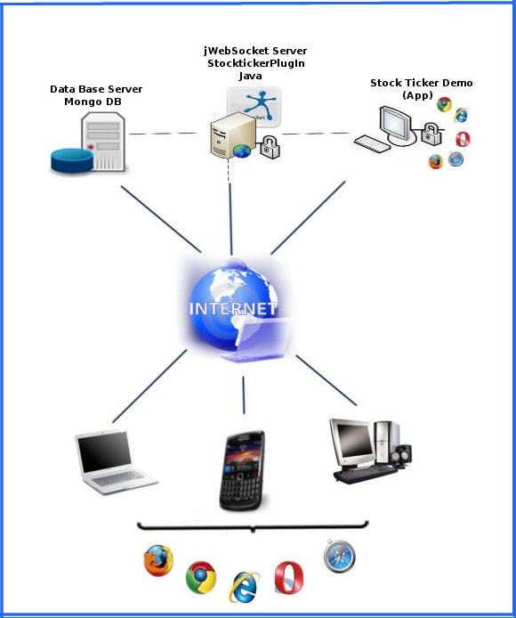
To access the Ticker Demo stock the client must use a browser that supports the WebSocket protocol. As soon as it connects to him to the application the user must be registered in the application and afterwards authenticate. One time in the application showed the state of the quotations of the undertakings, then is able to make his buy visualizing the in the table of deposits moreover it is able to see the state of this deposit by means of a graph y sell the reflex actions in the deposits. Each action that carries out the user will be sent to the jWebSocket servant, that it is the representative of keep him/her/it in the servant of base of data. This english needs to be overhauled, can hardly be understood.
7. Requirements for the use
To give am accustomed you to the Ticker Demo stock application it must have connection to Internet and use whoever of the navigators that support the protocol of WebSocket communication. Someone of them it is Google Chrome 4, Safari 5, Mozilla Firefox 8, operates 11 and Internet Explorer 10.
8. Roles of the solution
System User: it has access to all the functionalities that offers the system and it is in interaction with the same thing. What other roles are possible, how can a user take influence on that, why does he need to know this? What can he do if his access rights are not sufficient.
9. System Operation
Initial view: to access the application the user must be registered in the application and afterwards authenticate.
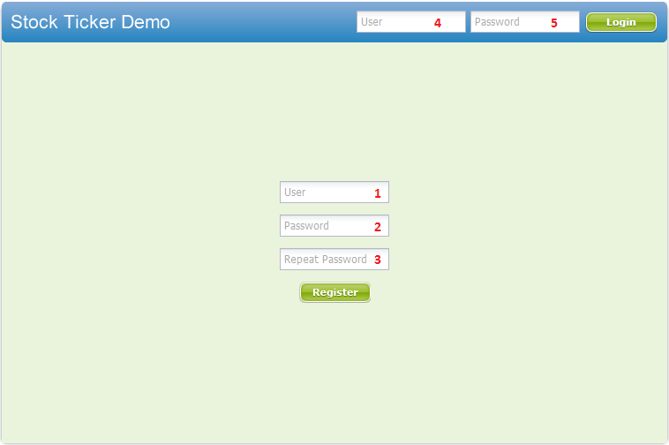
1 -------- Field for user the ID that will have in the application (username?)
2 -------- Field to insert user your password.
3 -------- Field where the user repeats the password to verify that is correct.
-------- Save user information.

4 -------- Field where the user introduces your ID to access the application.

5 -------- Field where the user introduces your password to access the application.

-------- Access the application.

Main view: When authenticating is shown the state of the quotations of the undertakings and the deposits of the authenticated user.
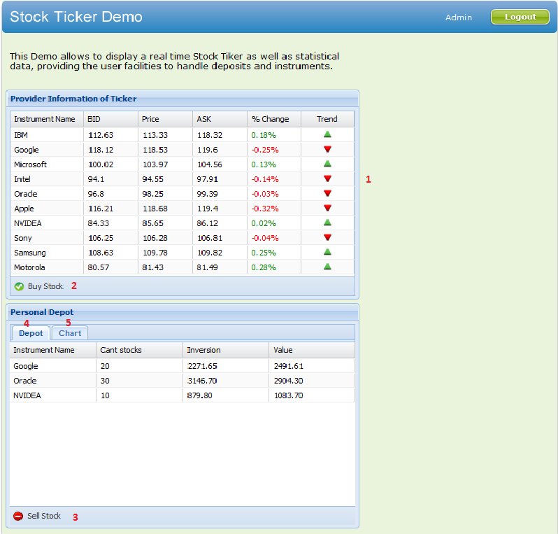

-------- Exits the application.

1 -------- Sample window that permits the user to see the state of the price of the die instrument a doubleclick in the same thing.

2 -------- Sample window that permits to the user makes his buy.

3 -------- Sample window that permits to the user makes his sell.

4 -------- Sample board in which will see to him reflected the deposit of the purchases of the user.

5 -------- Sample area where will be reflected the graphics of the deposits of the user.
Show historial of the price of the actions: when giving doubleclick in the row of the undertaking that you want to obtain the history of the price of his actions.
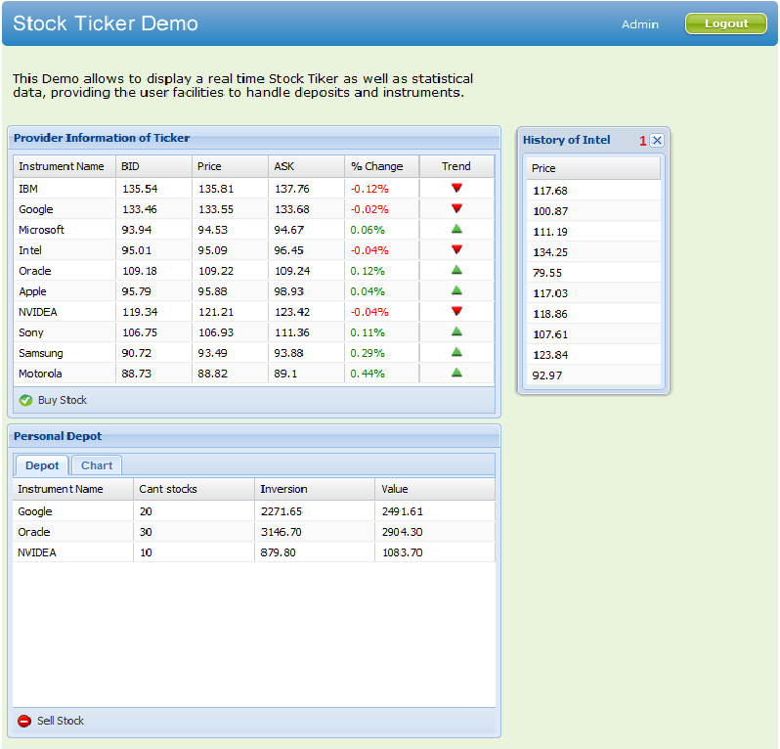
1 -------- Close the view.

To show view of the form to purchase: when giving click in the Buy Stock button How do I get to this view? Please explain.
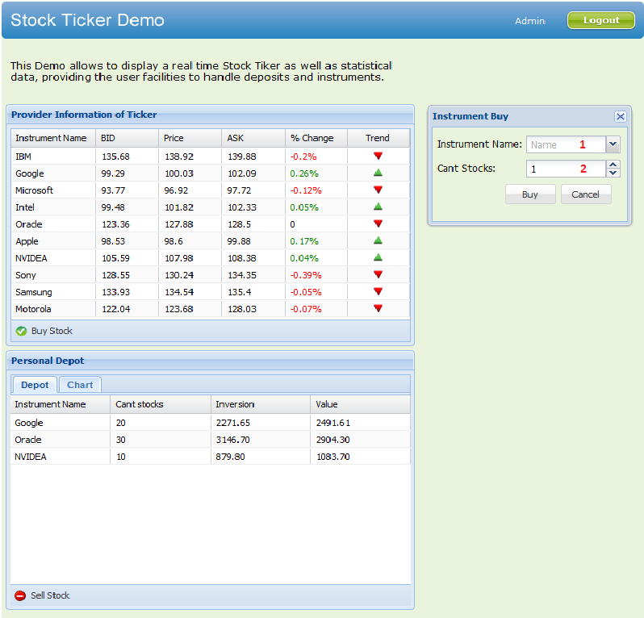

1 -------- Field where the user selects the instrument he wants to buy.

2 -------- Field where the user types the quantity of instruments he wants to buy.

-------- Buy the instrument.
-------- Canceling the purchase and closes the window.
To show the view of the form to do sell operations: when giving click in the Sell Stock button.

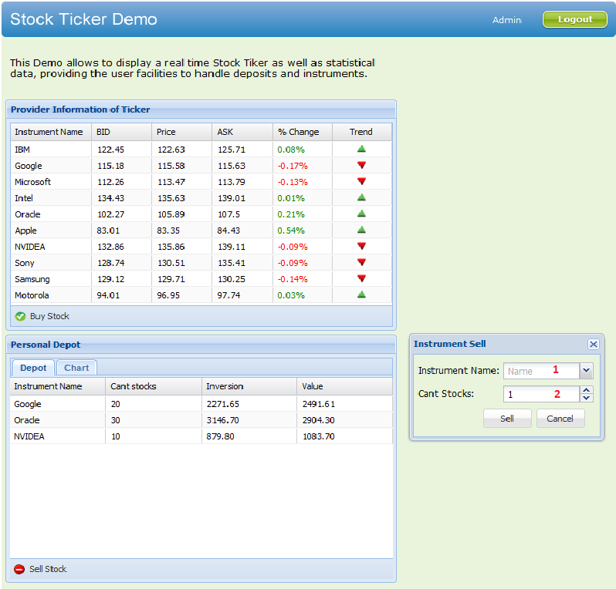
1 -------- Field where the user selects the instrument that he wants to sell.

2 -------- Field where the user types the quantity of instruments to sell.

-------- Sell the instrument.
-------- Canceling the sell and closes the window.

Showing graphics deposits of deposits: when giving click in the Chart eyelash
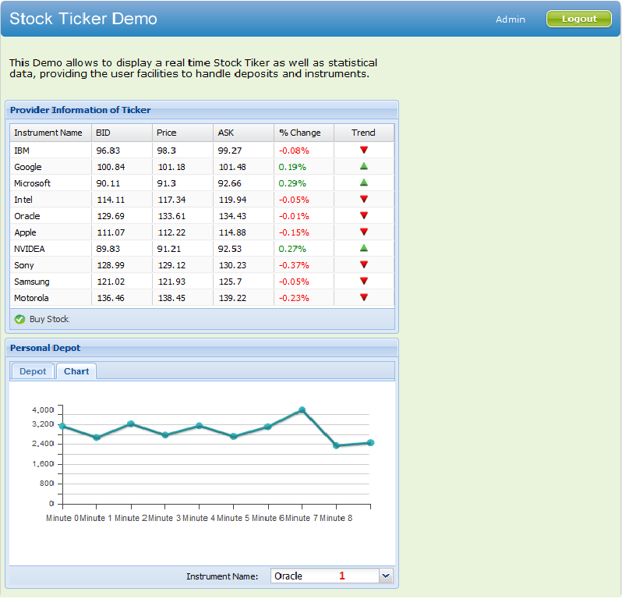
1 -------- Combobox to select the instrument that wants chart. A title in the chart window would be nice.

10. Rules of the solution
R1: If the user mistaken when repeating the password, during the process of register of user, the system display an error message and continues with the normal flow. Solution: The user must return to register securing to type the correct passwords.
R2: register of user, the system displays an error message and continues with the normal flow. Solution: The user must return to register inserting other user name.
R3: If the user it is mistaken when writing your user or password, during the process of access to the application, the system broadcasts a message of error and continues with the normal flux (english! see above). Solution: The user must again repeat his username and password.
R4: If the user introduces an user that doesn't exist, during the process of access to the application, the system broadcasts a message of error and continue with the normal flux. (english: see above) Solution: The user must be registered in the system.
R5: If the user doesn't select the instrument that wants buy, during the process of purchase of instruments, the system broadcasts a message of error and continues with the normal flux (english! See above). Solution: Selecting the instrument that wants buy.
R6: If the user during the process of purchase of instruments, wants buy an instrument that is not in your deposit of purchases, the quantity cannot surpass of 100 (why this limitation? Is this configurable?) or if the user buys an instrument that already exists in your deposit of purchases, the existent quantity more that wants buy cannot surpass of 100, otherwise the system broadcasts a message of error and continue with the normal flux (english, see above). Solution: Selecting an agreed quantity to which wants buy. I don’t see a reason to limit the number of instruments, why did you implement that?
R7: If the user doesn't select the instrument that wants sell, during the process of sale of instruments, the system broadcasts a message of error and continues with the normal flux (english, see aobve). Solution: Selecting the instrument that wants sell.
R8: If the user during the process of sale of instruments, wants sell an instrument, the quantity cannot surpass to the existent quantity, otherwise the system broadcasts a message of error and continue with the normal flux (english, see above). Solution: Selecting an agreed quantity to the values of your deposit .

